10.1.1

A message

Call from phone number: 937 542 8619

Khae. It's Todd. It's 2 o'clock in the afternoon. I want to met with you, Marco, and Aanya in my office in 10 minutes

Todd want to met in three minutes /met/

Hi Khae

It's time to go, now

Where?

Todd's office, in 2 minutes

Marco

What is it?

It's time to go, now

Where?

Todd's office. We have a meeting at ten past 2 'clock

In one minute?Yes

How do you go to the work in the morning , Marco?

I take the bus. I have a motorcycle but I only ride my motorcycle when it’s sunny.

How do you go to the work?

I take the subway. It’s fast.

How do you go to the work, Anaya?Do you drive car?

No. I don’t have a car.I ride my bicycle to work when it’s sunny. When it’s rainy I take the subway. /ˈsʌb.weɪ/

Oh. No.

Do you take the bus to work in morning, Aanya?

No, I don't take the bus

Oh. Then. Ah. Do you have a car?

No, Todd. I don't have a car

Oh. Okay. So how do you go to work?

When it's sunny, I ride my bicycle to work

Oh. that's nice. And when it's rainy?

When rainy, I take the subway

And Marco. Does he the subway to work?

No, he doesn't takes the subway to work

Oh. So, how does Marco go to work?

When it's sunny, he rides motocycle

And when it's rainy?

When it's rainy, he take the bus

What can Mike take to work today?

* He takes the subway

How does Rosa go to work?

* She takes the bus

Whar does Lily have?

* She has motocycle

How can Ted go to work today?

* He ride bicycle to work

How does Susan go to work?

* Susan drive a car to work, she doesn’t like the subway

How does Yoshi go to work today?

* Toshi take the bus to work on rainy day, when it’s sunny and warm, he walks. To day teh weather is good

What can Joan use today?

* She rides bicycle

What does the nam NOT like?

* The bus, it’s not fast

10.1.2

Where’s Todd?

Todd

Is he under his desk?

No. He next to the chair

Are you okay? Why you down there?

I’m not okay

We have for the meeting

What meeting?

Your message, the meeting in your office at 2:10 o’clock today

Today?

But Khae’s message...

It’s from last week

Today no meeting

No. **The meeting is not today, it’s on Monday at noon**

On Monday afternoon?

**At lunchtime?** /ˈlʌntʃ.taɪm/

That’s a bad time for a meeting, **we eat luch at noon**

**Can we have the meeting at 3 o’clock in the afternoon?**

No. **The meeting is not at 5 in the evening**. **It’s not at 11 in the morning**. **It’s at 12 o’clock in the afternoon**

Todd

What?

Your eye

**I have a dinner /with the Big Boss /at 8 o’clock /tonight**. Look at me. I’m terrible

I’m sorry

Be sad for me

Not for you, for the Big Boss

**Don’t go to dinner/ tonight, Go to dinner/ on Friday night**

No. The Big Boss want to go tonight

So no meeting now?

No. It’s on Monday

Okay. I have a call in 10 minutes with maketing

**See you at noon/ on Monday**

My eye

**I have a call in 10 minutes with /the product designers**. See you on Monday

Look at my eye

When Aanya, Marco, anad Khae get to Todd’s office, Todd is in his office but not his desk

When does Todd want a meeting?

* On Monday

Why does Marco say, “That’s a bad time for a meeting”?

* It’s his luchtime

When is Todd’s dinner with the Big Boss?

* Tonight

Why does Marco say to Todd, “Don’t go to dinner tonight”?

* Todd isn’t well

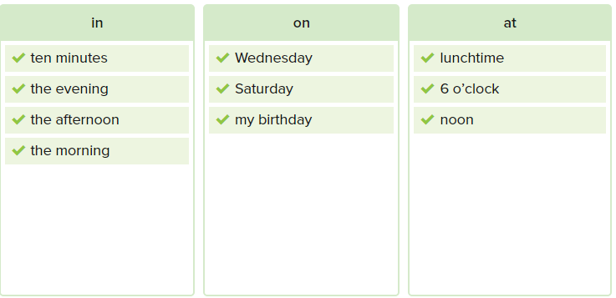

Do you have a call with marketing in 10 minutes?

No! I don’t have a call with marketing in 10 minutes

Are you okay with the meeting on Monday at noon. That’s at lunchtime

No, I’m not okay with that! I don’t want the meeting at luchtime

I know, It’s a bad time, but Todd is a boss. Oh well. Hey I play socket on Satuday morning and Sunday afternoon. Can you come?

Sorry. Saturday’s no good. On Saturday morning, I play tennis with my friends.

Well. Can you come on Sunday afternoon. We play at 4 o’clock in the afternoon on Sunday

I’m sorry, I can't! On Sunday afternoon, I go to the movie with my friends.

**Exercise**

I have a call with my boss in **ten minutes**

I’m sorry. Mr. Smith isn’t here now. Can you call him at **three o’clock**

Do you go to work **on** your birthday?

Have a goo weekend! See you **on Monday morning**

What time do you go to English class **in the evening**

The meeting is **on** Wednesday afternoon

Can you have luch with me **at noon today**?

When do you and your family eat dinner in **the evening**

Can you play tennis with me on **Sturday afternoon?**

**10.1.3**

**Look! A new restaurant for luch**

Good. I don’t like the food here

**When is it open?**

**It opens wednesday the 15th**

**Where is the restaurant?**

**The address is 1515 9th Street**

**Are there any lunch special?**

**Yes. On Monday, Tuesday and Thursday luch cost five dollars**

It is great!

Yes

Can we go there today?

Yes

What are Marco, Khae, and Aanya talking about?

* A new restaurant

When does the new restaurant open?

* Wednesday teh 15th

Where is the new restaurant?

* On Ninth street

When are these luch specials?

* On Monday, Tuesday, and Thursday

How much does a luch special cost?

* $5

When does the restaurant open?

* We’re new! We’re Pizza & Pizza! We open on Wednesday, August 25th

Where is Pizza & Pizza?

* Our address is 78 Maple Street.

How much does a pizza cost?

* All pizzas are only $9.00

What days is pizza & Pizza open?

* Monday, Tuesday, Wednesday, Thursday, and Friday.

What time does Pizza & Pizza open and close?

* HOURS: We open at 11:00 A.M. We close at 11 P.M.

What is pizza & Pizza’s telephone number?

* Do you want to order a pizza for delivery? Call 889-555-0000.

Hello

Hi, Tom. Mary . How are you?

I'm good . Thanks. How are you?

I'm good! I have a flyer for a . It opens

A new restaurant. That's great. what's the name of it?

It's The

Wow .A sandwich restaurant. I love sandwiches. Where is it?

The address is 22 Main Street.

Huh. I like sandwiches for breakfast .Do you know what the hours are what time does it open in the morning?

It opens at 7 o'clock.

And I love sandwiches for dinner. I leave work at 7 o'clock. Can I have dinner there?

No, you can't, It closes at 6 PM.

What is the name of the new restaurant?

The happy duck.

When does the restaurant open?

Sunday , August 2nd.

What is the restaurant’s address?

56 Airport road.

What time does the restaurant close?

At 11 PM.

When is there a special dinner menu?

Monday, Tuesday and Thursday.

On which day does dinner cost $10?

Thursday.

What is the phone number?

866-975-8046.

When it’s rainy, Hilda drives her car to class.

Keean takes the bus to work.

Brett likes to take the subway in New York City. It’s fast.

Zoe and Ellen like to ride their bicycles when it’s sunny.

Tim rides a motorcycle to work

Do you drive a car to work, Paul?

--> No. I don't. I don't have a car

How do you go to work?

I ride my bicycle when it is sunny. How do you go to work, Jilian?

--> I take the bus to work

When it’s rainy. I take the subway.

I have a motorcycle, but I only ride it when it’s sunny.

Dara: It’s Saturday. What time do you go to work on the weekend?

Julia: At six o'clock in the evening. Oh, no! It’s 5:45!

Dara: Can you get to your job in fifteen minutes on the bus?

Julia: No! The bus isn’t fast on Saturday. Can we drive your car?

Dara: Okay. It’s time to go, now.

Peng:  Do you have a meeting with the boss this afternoon?

Li: Yes, It’s on Thursday.

Omar: Does the new Thai restaurant open in June?

Tony:  No, it opens in July.

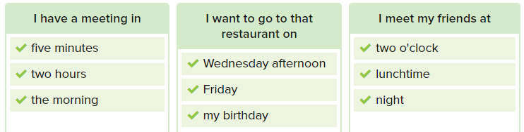

We can go to the movies on Saturday.

I have a new English class in twenty minutes . Can I drive your car?

Workbook

1 ride a motorcycle

ride a bicycle

drive a car

take the bus  
take the subway

walk

**Jim:** Is it sunny today?

Marco: Yes, it is. I want to ride my motorcycle to work.

Aanya: Do you drive a car to work, Khae?

Khae: No. I don't have a car.

Todd: How do you go to work in the morning?

Khae: I take the subway. It's fast, and it's good when it's rainy.

Todd: Milo lives in Hillsdale. Can he take the bus to work?.

Marco: No, he can't. The bus doesn't go there.

Todd: Where's Aanya?

Khae: She's tired, and she needs to drink some water. She rides her bicycle to work.

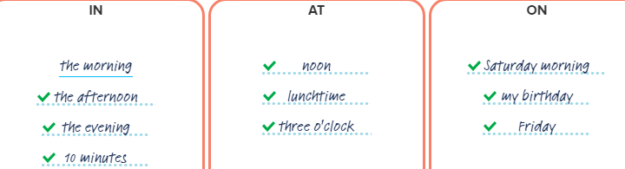

1 I eat cake on / in / at my birthday.

2 Marco, come to the meeting in 15 minutes.

3 Can Todd and Aanya eat lunch at one o’clock?

4 Todd watches TV in the evening.

5 We play football on Sunday afternoon.

6 Does Aanya drink coffee in the morning?

7 Khae starts work at nine o’clock.

8 My English class is on Tuesday.

Cho: How do you go to work, Iris?

Iris: I take the subway. What about you?

Cho: I drive my car to work. But when it's sunny, I ride my bicycle.

Iris: That's cool. …Hey, do you want to eat lunch with me today?

Cho: Yes. I can eat lunch at noon.

Iris: Oh. I have a meeting then. Can you eat at one o'clock?

Cho: No, I can't. Can we have lunch on Wednesday?

Iris: No, but I can meet you in the evening at five o'clock.

Cho: Great!

1 Joan takes the subway to work.

2 Rosa takes the bus to work.

Why? Because she doesn’t have a car.

3 Today, Mike takes the subway to work.

When it's sunny Mike rides his bicycle.

4 Lily takes a motorcycle to work.

Why? Because she likes it and It's fast.

1 What is the name of the restaurant?

The name of the restaurant is Palazzo pizza place.

2 What food does the restaurant have?

The restaurant have pizza.

3 When does the restaurant open?

The restaurant opens on Friday May 1st

4 What is the address?

The address is 14 Market street

5 Can you eat at the restaurant at ten o'clock in the morning?

No, I can't

6 Can you eat at the restaurant at nine o'clock in the evening?

Yes, I can

7 How much is pizza on Monday at lunchtime?

It costs 10 dollars

8 What is the restaurant's phone number?

The restaurant's phone number is 333-9192

1 How does Polly go to work?

Polly takes the bus to work.

2 Can Polly and Mario drive a car?  
No, they can't.

3 What do teachers and students do in Number One classes?  
They drive a car.

4 When are the classes?

The classes is on Monday to Friday , in the morning , in the afternoon and in the evening.

5 When can you drive to work?

I can drive to work every day.

6 What is the phone number for the classes?  
The phone number for the classes is 524-3789.

7 What is the address for the classes?

The address for the classes is 57 Melwood Drive Forest City.